Title

**Application of Image Processing to Roundabouts’ Circulating Headway Determination**

**Abstract**

Gap acceptance models are applicable in determination of capacity of unsignalized intersections. In roundabouts, determination of circulating headway is one of the steps necessary to obtain critical gap, an input in the capacity models. A well-known technique to headways determination involves manually recording the time events from videos recorded at intersection. However, this process is time consuming and is associated with human errors during the process. This paper presents a tool for determination of the circulating headways using image processing techniques which begins with processing techniques like foreground detection, morphological operations and developing region of interest leading to the headways determination. The techniques have been programmed and implemented through Matlab software. For the first seven vehicles recorded, the proposed method shows comparably similar results to that determined manually, with an additional reading (noise) coming from recording a single vehicle twice. The method can effectively determine the locations of headways and

**Introduction:**

Capacity analysis of roundabouts utilizes the gap acceptance theory. Roundabouts’ capacity determination involves collection of circulating vehicles’ headways for determination of critical gap. Collection of the circulating headways have been done manually through video observation and hence record of the said events. Another option, has been to semi-automate the process by creating a program which records timestamps of events associated with passage of a circulating vehicle through a reference point in the video.

The processes mentioned, since they involve human decisions upon the event, are not free from human errors in correctly recording the time events. In addition, the process is time consuming since a single video has to be played more than one times if an anticipated accuracy is to be expected.

This paper aims at utilizing the image processing methods in determination of gap acceptance parameters at roundabouts. Since the process runs solely depending upon computer vision, it involves reduced human errors and expedited extraction process.

**Related Works**

An attempt to use image processing in study of traffic flow operations and vehicle detection has been applied as substitute to human vision in much of literature. The studies range from incorporating feature detection methods from still images to foreground detection methods in video imaging.

Kembhavi, Harwood, & Davis, (2011) [1] developed a vehicles detector from aerial images by incorporating rich set of image descriptors which includes color probability maps. Their tool involved image properties like Color Probability Maps, Histograms of Oriented gradients and Pairs of Pixels (PoP) methods. The vehicles features were then extracted through the use of Partial Least Squares classification after training the images.

**Data Used and Study design**

To carry out this study, a multilane roundabout at N 40th Street @ E Hanna Avenue located in Tampa, Fl was used. The approach with two lanes conflicted with one lane circulating was used. From the circulating lane, a region closer to conflict region was selected as a region of interest (ROI). Within this region the change in cell values is traced to detect the times when the vehicles pass through the point.

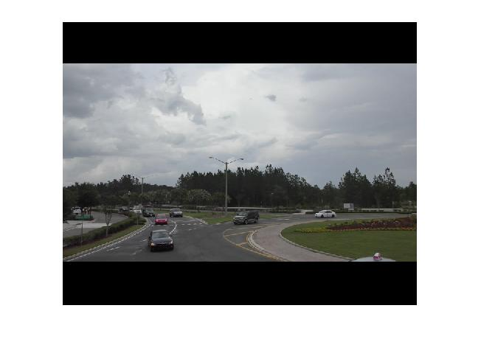

Region of interest

The approach is to apply image processing techniques which results into detection of foreground. The detected foreground is then masked with the region of interest to trace the change in cell values at region of interest in the foreground. The following are steps leading to determination of the headways

1. Background modeling
2. Foreground detection
3. Morphological operations
4. Determination of region of interest
5. Headways determination

**Background Modeling**

Background modeling involves creating a reference image that would refer to features that were defines other features of the image from the This is an important component in the motion analysis. Several methods to obtain the background have been developed [2,6,7,8,10]. [2] classifies techniques into two major categories, recursive techniques and non-recursive techniques. Recursive techniques need no formation of buffer of several frames for modeling foreground [3]. Non-recursive techniques involve creating a buffer of frames and then estimates a background image based upon the temporal variation of each pixel within a buffer [2]. A mathematical operation is then applied to the buffer to form a background frame. The mathematical approaches applied to that background range from average filter, median filter and linear predictive filter. Median filter determines the median value of all the cell values in the background.

In this paper, a median filter mechanism was applied to model the background. Background subtraction is determined by finding the median value of the given pixel numbers. a number of frames are selected from the video and median value for each pixel is determined. For this method, considering a video with n frames, where we have to pick k frames for background, the video was divided into n/k parts and from each portion 1 frame chosen as a representative. The median value for such frame was chosen. a value of k was chosen depending upon the quality of the foreground obtained. For this study, a 20 frames buffer was used for the determination of background.

**Foreground Detection**

Foreground detection is done by comparing the background generated with the original frames. A threshold of the difference between the frames is chosen that will filter the background and retain the foreground. According to [3] a good foreground is obtained if the values are normalized, that is: the pixel difference is divided by the original frame values. A threshold is also chosen such that, it will remove the noise of the background in the foreground without affecting the quality of the foreground

**Morphological Operations**

Morphological operations are applied to the foreground detected for the purpose of removing noise. Several morphological operations are done to the foreground to remove the unwanted noise. The existing morphological operations are such as disk, open and closed operations are done. Considering the foreground obtained, the suitable operation was closed operation. This modified the foreground to fill in the voids in the foreground.

**Filtering Mechanism**

Filtering of the foreground is one of the important step in getting a clear foreground for further processing. In this paper a closing morphological filter the image was done following creation of a disc structural element that is used as a reference for filtering the background

**Headway determination**

A region of interest is chosen that reflects the point of entrance to the conflict region. A change in pixel values of masked binary image of the region of interest will reflect the presence or absence of a vehicle. Graphically, the filled area variations can be plotted against frame number which shows the frame intervals where there is presence of vehicles. Figure xxx(b) shows the pixel distribution showing peaks reflecting the presence of vehicle in ROI and other regions with zero values showing the absence of vehicles. Though selection of suitable threshold, a plot specifying a frame number where the area becomes greater than threshold is specified as shown in Fig …(b).

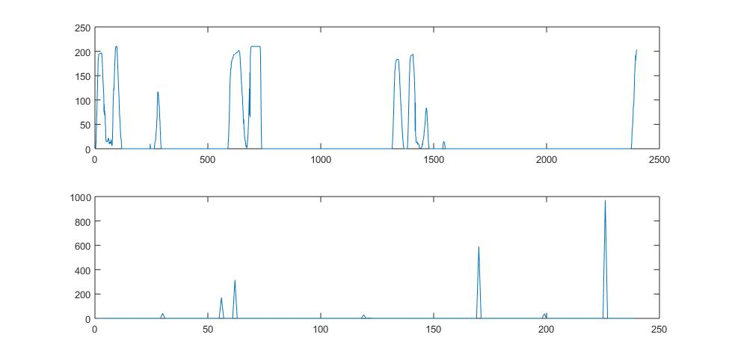

**Results**

From the obtained frame numbers, the timestamps are determined through dividing frame number by the frame rate which is 30frames per second. The timestamp difference between successive vehicles gives the headway values. Table xxx summarizes frame numbers, timestamps as well as headways of circulating vehicles’ arrival events.

Table of results:

|  |  |  |  |  |  |  |  |
| --- | --- | --- | --- | --- | --- | --- | --- |
| Frame number | 8 | 80 | 594 | 686 | 1322 | 1388 | 2387 |
| Time (sec) | 0.267 | 2.667 | 19.800 | 22.867 | 44.067 | 46.267 | 79.567 |
| Headway(sec) |  | 2.400 | 17.133 | 3.067 | 21.200 | 2.200 | 33.300 |

**Validation**

Manual process of recording of the headways was done to determine accuracy of using the proposed method. The headway distribution according to manual approach is as follows:

|  |  |  |  |  |  |  |  |
| --- | --- | --- | --- | --- | --- | --- | --- |
| Time (sec) | 0.30 | 2.62 | 19.54 | 43.93 | 45.91 | 78.94 | 79.57 |
| Headway(sec) |  | 2.32 | 16.92 | 24.39 | 1.98 | 33.03 | 0.63 |

The comparison reveals that the for the first 80 seconds, 7 vehicles passed the point, to obtain 6 headway values. 6 headway values are obtained while the IP method has missed correlation between the manual headway and the calculated headway reach up to … percent. This implies that the proposed method is has an accuracy of …. Percent compared with manual record of events.

Graph: Relationship between IP Vs Manual

The discrepancy resulted at some points is attributed to two things. One is the overlap of vehicle images and blockage of region of interest by turning vehicles. Due to lower orientation angle of the camera, the vehicles may appear overlapping causing headway detection difficult to determine. Different from the straight portion of the roadway, the vehicle trajectory involves turning maneuver, which may also block the region of interest and hence appear as an intersection. Understand

The solution to this problem would be increasing the height for recording especially use of aerial graphics from drones or high rise points.

# References

|  |  |
| --- | --- |
| [1] | A. Kembhavi, D. Harwood and L. S. Davis, "Vehicle Detection Using Partial Least Squares," *IEEE Transactions on Pattern Analysis And Machine Intelligence,* pp. 1250-1265, 2011. |
| [2] | M. a. e. A. Marzouk, "Modified Background Subtraction Algorithm for Motion Detection in Surveillance Systems," *AMARABAC, Journal of American Arabic Academy of Sciences and Technology,* vol. 1, no. 2, pp. 112-123, 2010. |
| [3] | H. Hassanpour, M. Sedighi and A. R. Manashty, "Video Frame’s Background Modeling: Reviewing The Techniques," *Journal of Signal and Information Processing,,* pp. 72-78 , 2011. |
| [4] | E. Altay, B. A. Güvenç and L. Güvenç, "Lidar Data Analysis for Time to Headway Determination in the DriveSafe Project Field Tests," *International Journal of Vehicular Technology,* p. 9, 2013. |
| [5] | A. Tourani and A. Shahbahrami, "Vehicle Counting Method Based on Digital Image Processing Algorithms," in *2015 2nd International Conference on Pattern Recognition and Image Analysis (IPRIA 2015)* , Rasht, Iran, 2015. |
| [6] | A. G. Rad, A. Dehghani and M. R. Karim, "Vehicle speed detection in video image sequences using CVS method," *International Journal of the Physical Sciences,* vol. 5, no. 17, pp. 2555-2563, 2010. |